Title | AI Calibration Procedure
Distribution
Author | Jax Yang |  | Date | 2013-03-05
Review |  |  | Date
Approved |  |  | Date
Approved |  |  | Date
Remarks
Contents

1 Preparation 3
1.1 Definitions, acronyms, and abbreviations 3
1.2 Connect the calibration system 3
1.3 Switch on power supply 3
2 Calibration 3
2.1 Enable AI input 3
2.2 Check AI Hardware 4
2.3 Start calibration 4
2.4 Calibrate Lower point 4
2.5 Calibrate Upper point 4
2.6 Stop calibration 4
3 Calibration validation 4
3.1 Validate 4mA point 4
3.2 Validate other points 4
3.3 Calculation 4
4 Appendix 5
4.1 Command: 48 Read Additional Device Status 5
4.2 Other commands 5
5 References 6
6 Revision History 6

List of Figures
xx

List of Tables
xx

Preparation

Definitions, acronyms, and abbreviations

Term  M1  M2 | Definition  Hart Modem #1  Hart Modem #2

Connect the calibration system
Connect the calibration system as Figure 1.
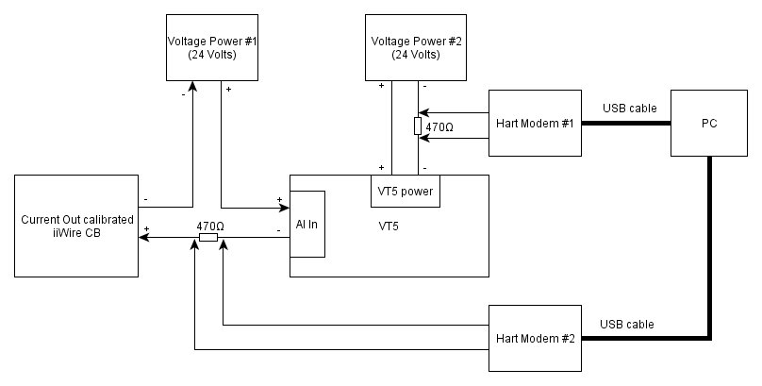
Figure 1 Calibration system
Notes:
The current out of iiWire CB which is used as calibration current source should be calibrated before using.

Switch on power supply
Switch on power supply Voltage Power 1# and 2#.

Calibration

Enable AI input
Select AI input as density via sending command 131(slot code is 3) to M1 to write Ai Selection (value is 3 )

Check AI Hardware
Read status of VT5 via sending command 48 to M1. If the 1th bit diagDeviceStatus[3] is set, that indicate an AI SPI COM error occurred. The calibration should be terminated and need to check the hardware of the product. Please refer to command 48 for details. For example, suppose diagDeviceStatus[3] = 0b0000 0001, there is an AI SPI COM error.

Start calibration
Set the current input as 4 mA(±0.4mA) via sending command 40 to M2, then start calibration via sending command 131 to M1(slot code is 18,value is 1).

Calibrate Lower point
Write the actual current input as setting in step2.2 via sending command 141 to M1(slot code is 108).
For example, suppose the input is 4.038mA, trimAiLowerEndpoint should be set as 4.038.

Calibrate Upper point
Set the current input as 20 mA (±0.4mA)via sending command 40 to M2, then Write the actual current input as setting via sending command 141 to M1 (slot code is 109).
For example, suppose the input is 20.128mA, trimAiLowerEndpoint should be set as 20.128.

Stop calibration
Stop calibration command via sending command 131 to M1 (slot code is 108, value is 2)

Calibration validation

Validate 4mA point

5 seconds later after step 2.6, set the current source as 4mA(1st Validation point) via sending command 40 to M2, then read back the actual current input via command 180 from M1.

Validate other points
Validate 8mA,12mA,16mA,20mA points as step 3.1.

Calculation

Compare the actual current sampled by VT5 with the input value set at step 3.1, calculate the relative error. The maximum relative error should be less than 5‰ .

Relative Error = |Absolute Error|/actual input * 100%

Appendix

Command: 48 Read Additional Device Status
Command type | Object name | Order | Data type | Count | Enum Values | Enum Names
REQ+RES | diagDeviceStatus | 0 | (TUSIGN8) | 6 | --- | ---
REQ+RES | extendedDeviceStatus | 1 | (TUSIGN8) | 1 | 0  1  2  4 | DEFAULT_EXTENDED_DEVICE_STATUS  MAINTENANCE_REQUIRED  DEVICE_VARIABLE_ALERT  CRITICAL_POWER_FAILURE
REQ+RES | operatingMode | 2 | (TUSIGN8) | 1 | 0  1  2  3  4  5  6  7  8  9  10  11  12 | LIQUID_ACTUAL_VOLUME  LIQUID_NORMAL_VOLUME  LIQUID_MASS  LIQUID_POWER  GAS_ACTUAL_VOLUME  GAS_STANDARD_VOLUME  GAS_MASS  GAS_POWER  BIOGAS_ACTUAL_VOLUME  BIOGAS_STANDARD_VOLUME  STEAM_ACTUAL_VOLUME  STEAM_MASS  STEAM_POWER
REQ+RES | dummyU8 | 3 | (TUSIGN8) | 1 | --- | ---
REQ+RES | dummyU8 | 4 | (TUSIGN8) | 1 | --- | ---
REQ+RES | dummyU8 | 5 | (TUSIGN8) | 1 | --- | ---
REQ+RES | dummyU8 | 6 | (TUSIGN8) | 1 | --- | ---
REQ+RES | dummyU8 | 7 | (TUSIGN8) | 1 | --- | ---
REQ+RES | dummyU8 | 8 | (TUSIGN8) | 1 | --- | ---
REQ+RES | diagnosisHighCondition | 9 | (TUSIGN8) | 1 | --- | ---
REQ+RES | diagnosisHighClass | 10 | (TUSIGN8) | 1 | --- | ---
REQ+RES | diagnosisHighGroup | 11 | (TUSIGN8) | 1 | --- | ---
REQ+RES | diagHistory | 12 | (TUSIGN8) | 6 | --- | ---
REQ+RES | dummyU8 | 13 | (TUSIGN8) | 1 | --- | ---
REQ+RES | dummyU8 | 14 | (TUSIGN8) | 1 | --- | ---

Notes:
If the 4th bit diagDeviceStatus[3] is set, that indicate an AI SPI COM error occurred. The calibration should be terminated and need to check the hardware of the product.

Other commands
Please refer to HARTCommandDescription.html

References
Ref. | Document
[1] | HARTCommandDescription.html of VT5
[2]

Revision History
Rev. | Description of Version/Changes | Primary Author(s) | Date
0.1 | Initial revision. | Jax | 2012-11-29
0.2 | 1.Rewrite the document based on template  2.Use iiWire CB as calibration current source | Jax | 2012-11-30
0.3 | Modify the validation section | Jax | 2012-11-30
0.4 | Modify the “Check AI Hardware ” step about the AI com error bit according to latest firmawre | Jax | 2013-03-05

